Uno User Game Guide

By: Christopher Nguyen

TABLE OF CONTENTS

Page

Rules of Christopher Nguyen’s UNO 3

What I could have add to my program 4

# Rules of Christopher Nguyen's UNO

First you must run the game through google chrome.

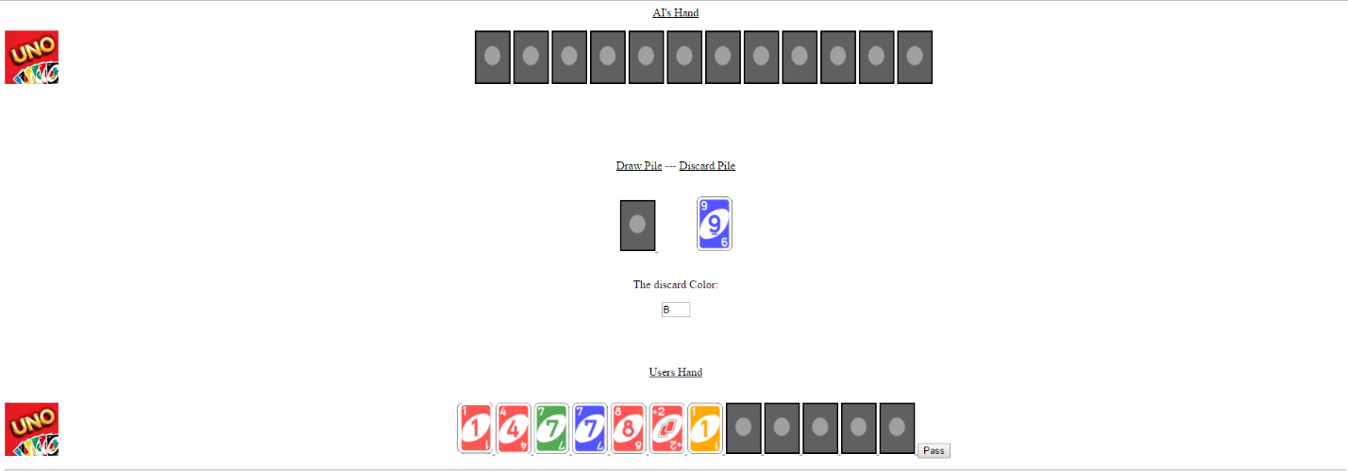

This is the pass button

These are playable cards in your hand

This is the draw Pile

This is the discard Pile Image

This text box tells you the discardColor

At the beginning of the game, the game will ask you to draw 7 cards from the draw pile image like the original game and to place a card in discard pile you must match the cards value or card color in your hand with the discard Pile card value or color. Your goal is to empty your hand before the AI does, if you don't have a card that matches the value or color then draw a card by clicking the image under draw pile and if you still can't do anything you must click the pass button to continue.

There are 4 different colors, R for Red, B for Blue, Y for Yellow and G for Green

Card Color is the outside area of the value

**Special Cards**  
Wild Card  
E:\Uno Program\13B.gif

Card Value will be in the middle

Currently this is called the Wild card it allows the player to change the discard Color to anything the player wants. It does not have to match discard Value or discard Color of the discard card to be placed in the discard pile.

Skip Card

E:\Uno Program\10B.gifE:\Uno Program\10R.gifE:\Uno Program\10G.gifE:\Uno Program\10Y.gif

This card can be used by the AI/Player to skip each other’s turn and go again. It can only be used when its card Color matches the discard Color.

**Disclaimer!**

**E:\Uno Program\11B.gifE:\Uno Program\11R.gifE:\Uno Program\11G.gifE:\Uno Program\11Y.gif E:\Uno Program\12B.gif E:\Uno Program\12R.gif E:\Uno Program\12G.gif E:\Uno Program\12Y.gif**

**Currently these two cards do not have any special features, currently they act like normal card. The reverse card is the value of 11 while the +2 meaning draw 2 card acts as the value of 12.**

# What I could have added to my program

When I added disclaimers into my rules it meant the game wasn’t fully original. There were two cards that had special features that I could have added in, but if I did I would have to add more. Like if I added the reverse card it would reverse the way whose turn it is but with two players, reversing someone’s turn would only end the turn but if it was three players it would be different because instead of this Ai going the other one goes. So, I would have to add another AI to use that card’s feature. Then, I would also have to create a deck for it and there would be four possible turns instead of the three, which I have currently. Also for the draw +2 when you place it down you make the other player or AI draw two cards and vice versa for the AI and I would also have to add another nested if statement within another and within another, but since I am running out of time I cannot add the cards feature because it would probably take me 6 hours to code. Sadly, the problem is that I have no time due to exams and I also must do my flow charts. So, in conclusion I could have added the features of reverse and draw two but I had no time.

Known Errors for **Internet Explorer**. Note: Google Chrome works 100%

* There is one known **logic error** that doesn’t allow some images to be shown while loading.